ASSIGNMENT 4
Implementation of AWS Identity and Access Management (IAM)
Topic: Creating an IAM User and Testing Service-Specific Permissions (S3 Full Access)
Objective :
The primary objective of this assignment is to demonstrate how to create a secure IAM user in AWS, assign specific managed policies (AmazonS3FullAccess), and verify that the user can only access authorized services while being restricted from others (like EC2 and Billing).

Step 1: Accessing IAM Users Dashboard
The AWS Identity and Access Management (IAM) dashboard. The user is on the "Users" page, which currently shows zero users. The "Create user" button is highlighted to start the process.
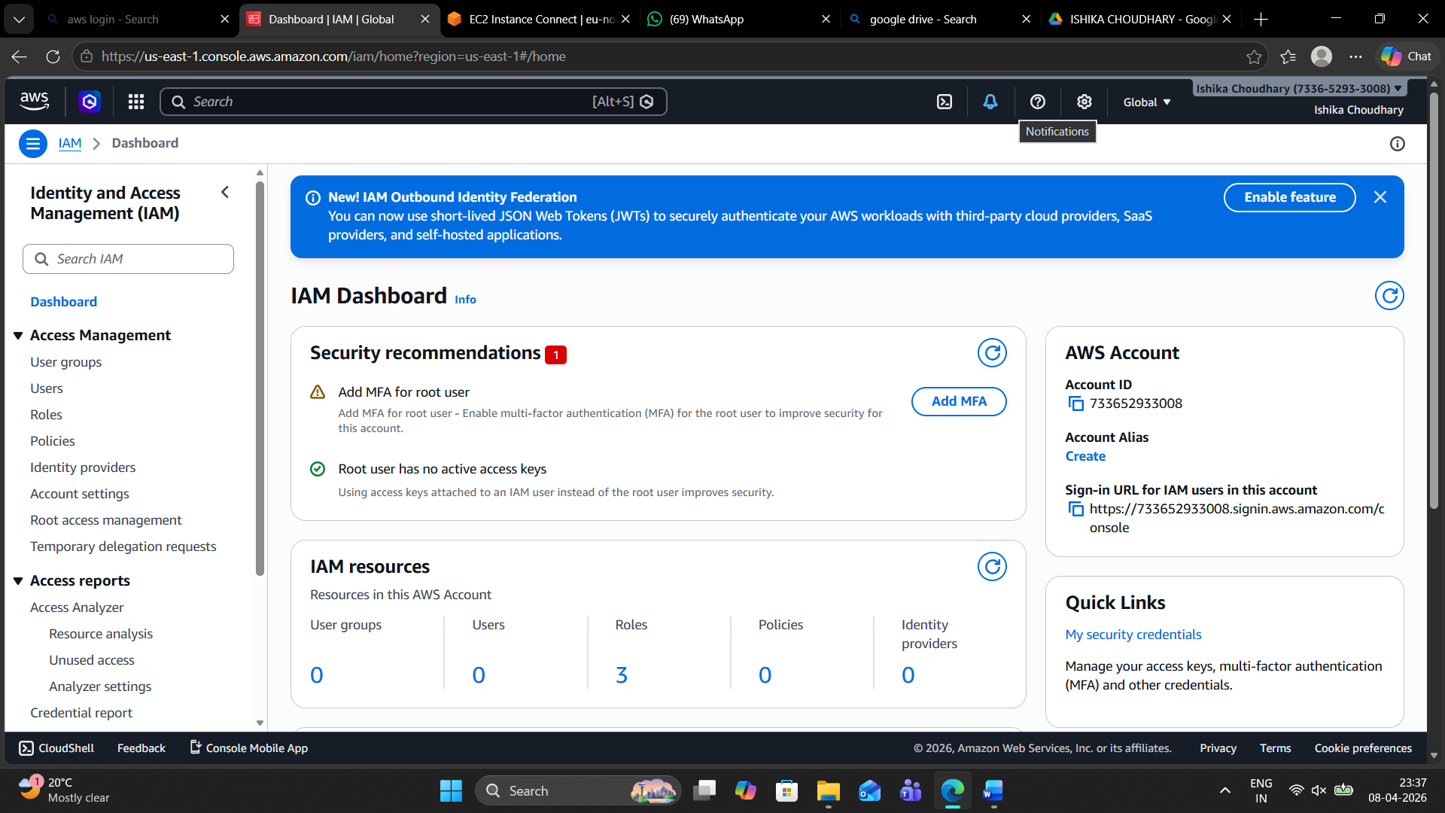

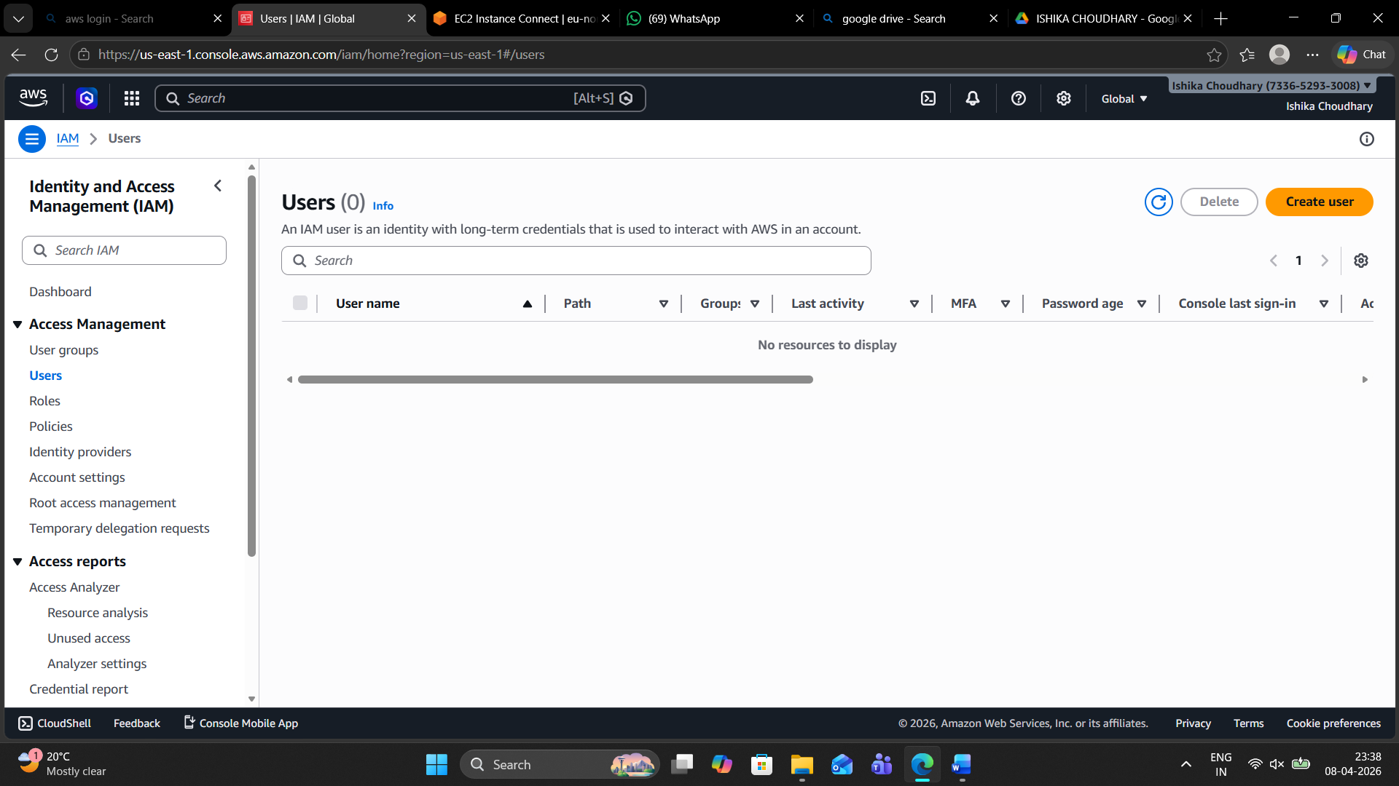

Step 2: Specifying User Details
In this step, the user name is set as "Ishika@choudhary09". The option "Provide user access to the AWS Management Console" is checked, and "Autogenerated password" is selected for the login credentials.
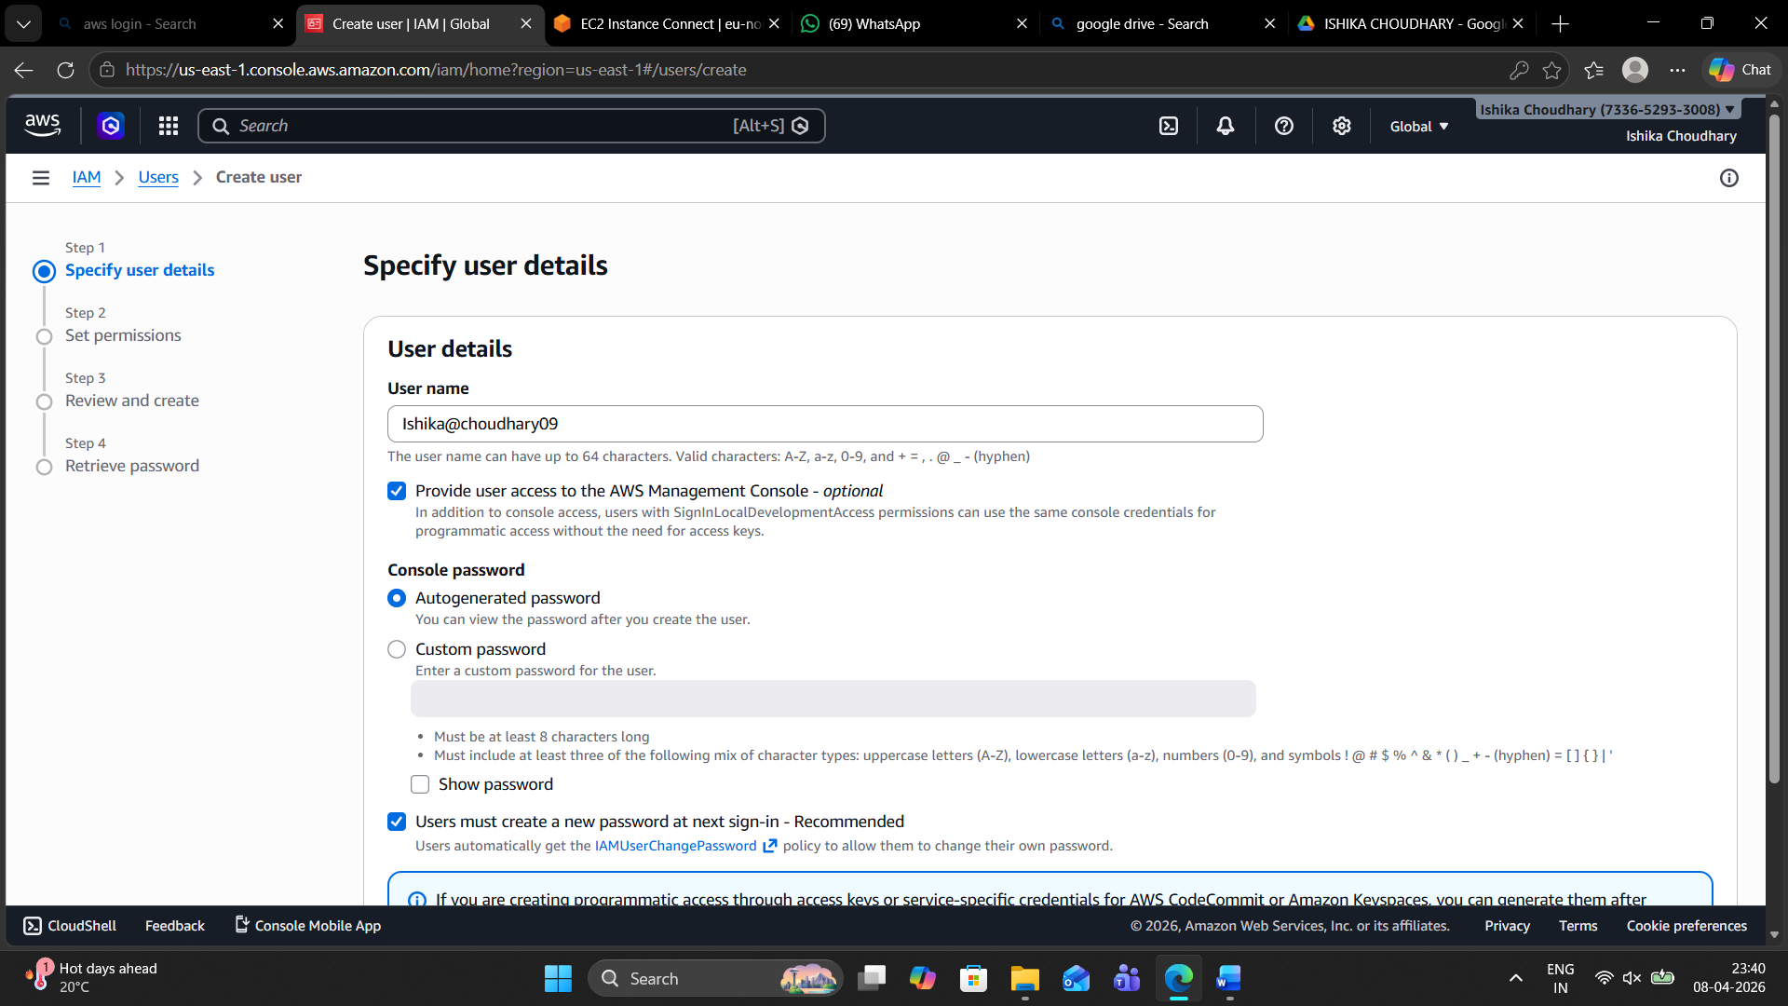

Step 3: Permission Options
This "Set permissions" phase. Three options are visible: "Add user to group," "Copy permissions," and "Attach policies directly." The "Add user to group" option is initially highlighted.
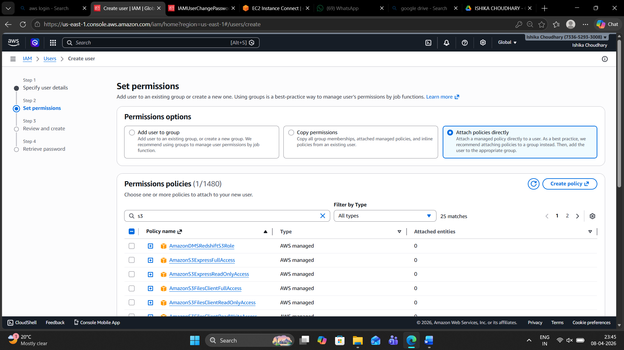

Step 4: Attaching Permissions Policy
The user has selected "Attach policies directly." In the search bar, "s3" was typed, and the policy "AmazonS3FullAccess" is checked to give the new user full control over S3 services.
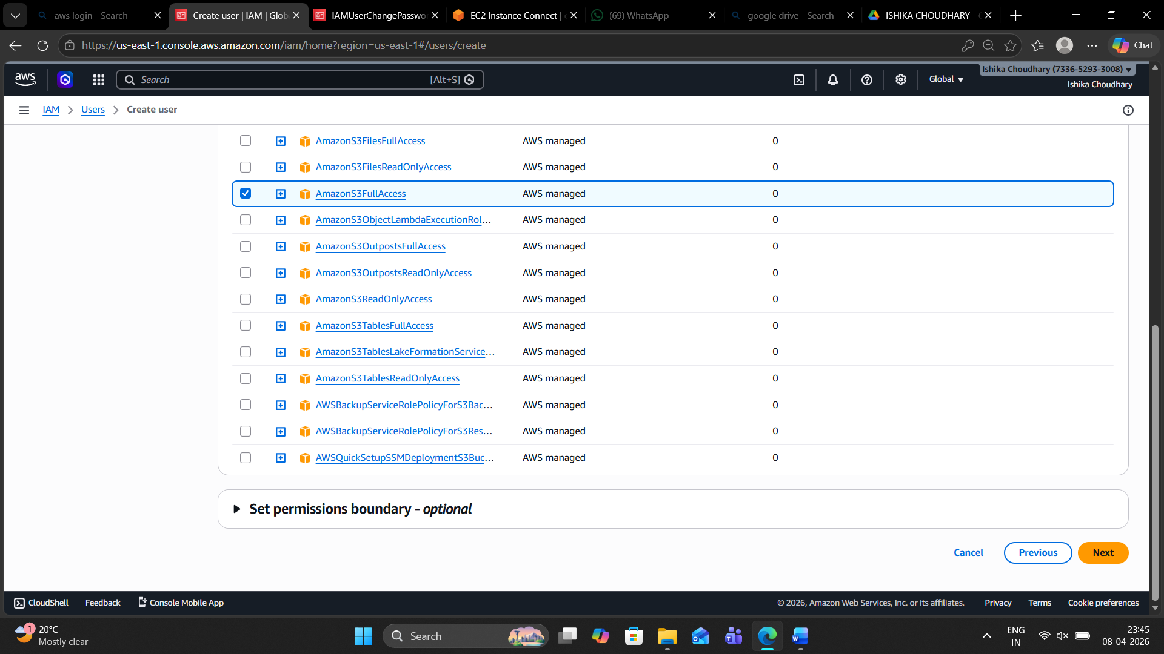

Step 5: Review and Create
A summary page appears showing the user name (ishika), the chosen password type, and the attached permission policy (AmazonS3FullAccess). The "Create user" button is ready to be clicked.
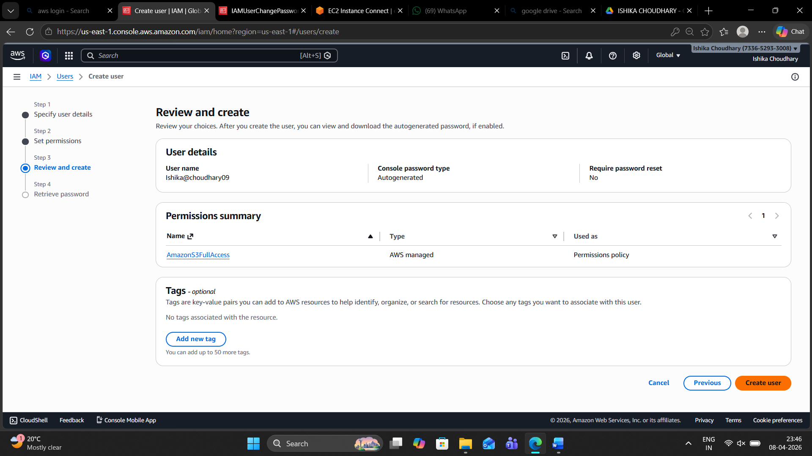

Step 6: User Created Successfully
A green success banner confirms that the user has been created. This page provides the Console sign-in URL, the username, and a hidden password that can be revealed or downloaded as a .csv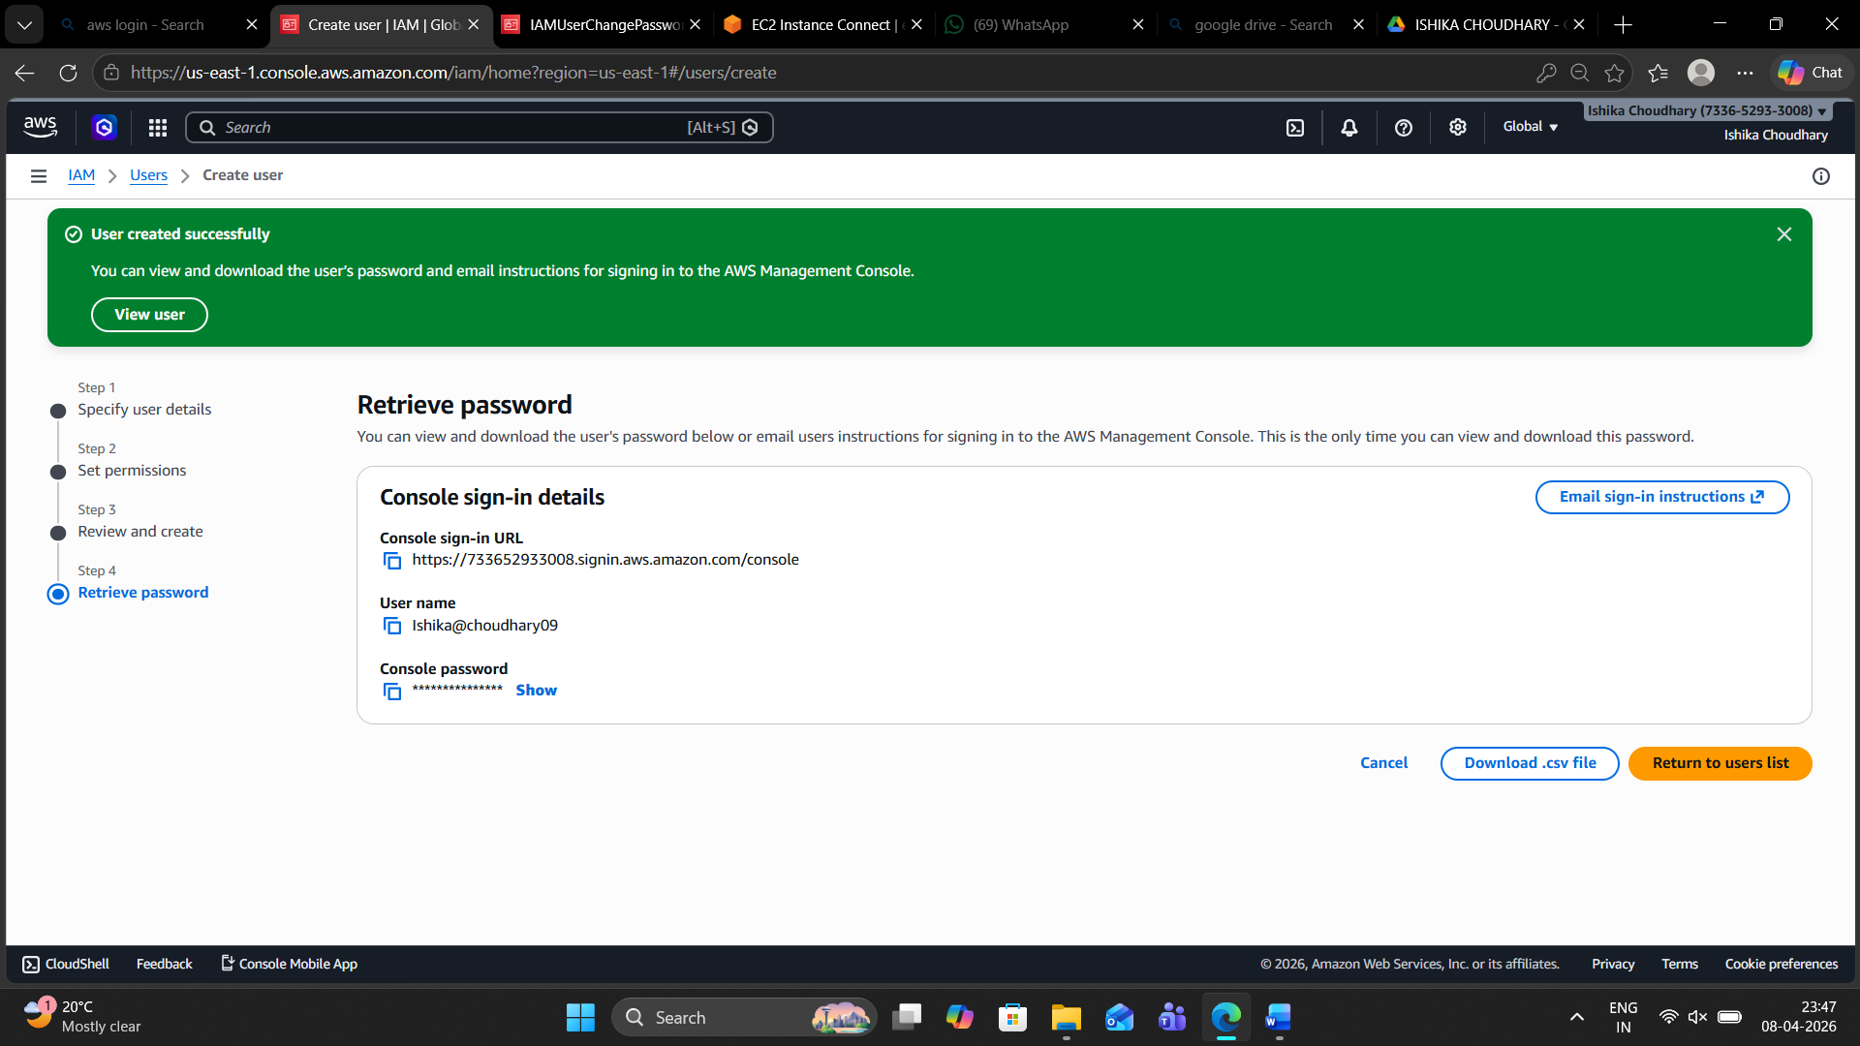

Step 7: Entering the Sign-in URL
The user is shown pasting the specific AWS console sign-in link (containing the Account ID) into the browser's address bar to access the login page.

Step 8: IAM User Sign-in
The official AWS login page is shown. The Account ID, IAM username (ishika), and the autogenerated password are entered into the fields. The user is clicking "Sign in."
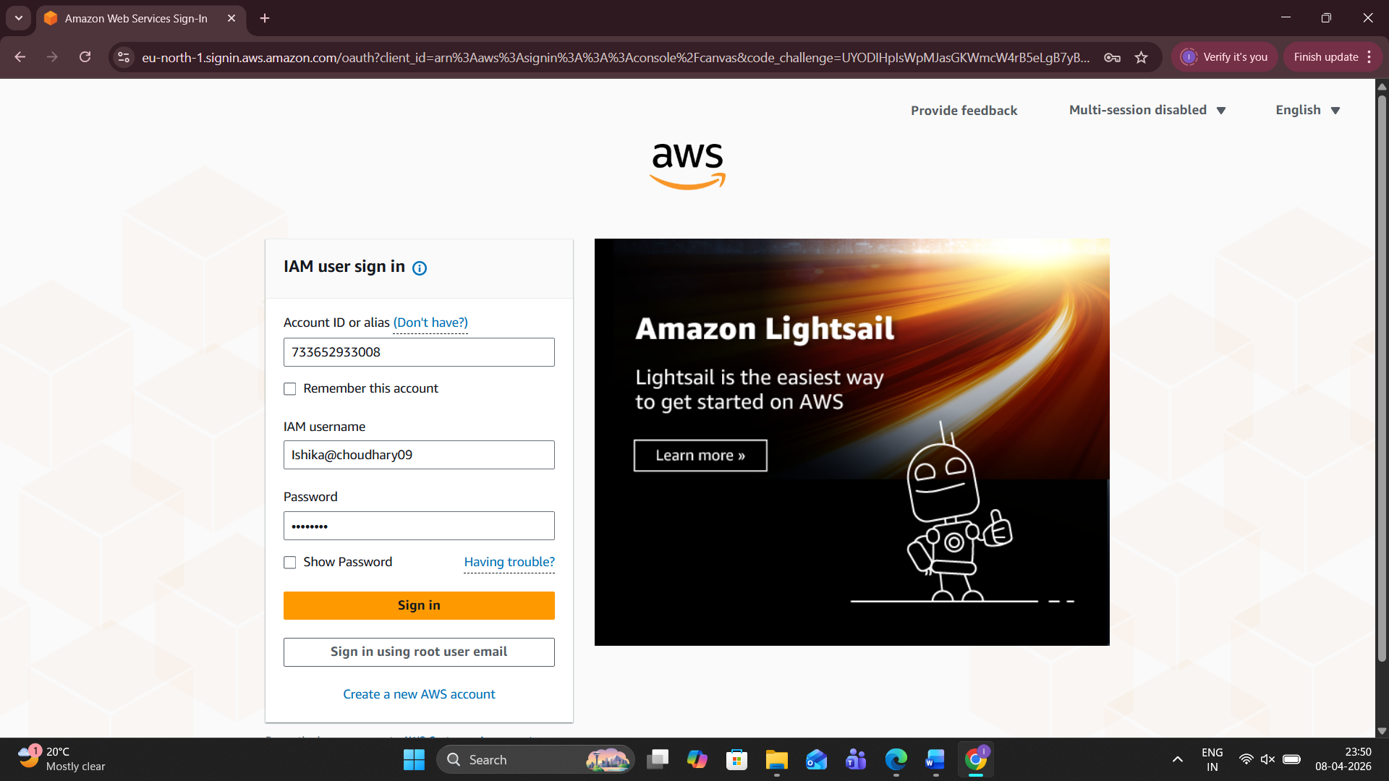Step 9: Successful Login & Console Home
The AWS Management Console home page after logging in as the IAM user "ranjeet." The top right corner confirms the login identity, and the user is now ready to use AWS services.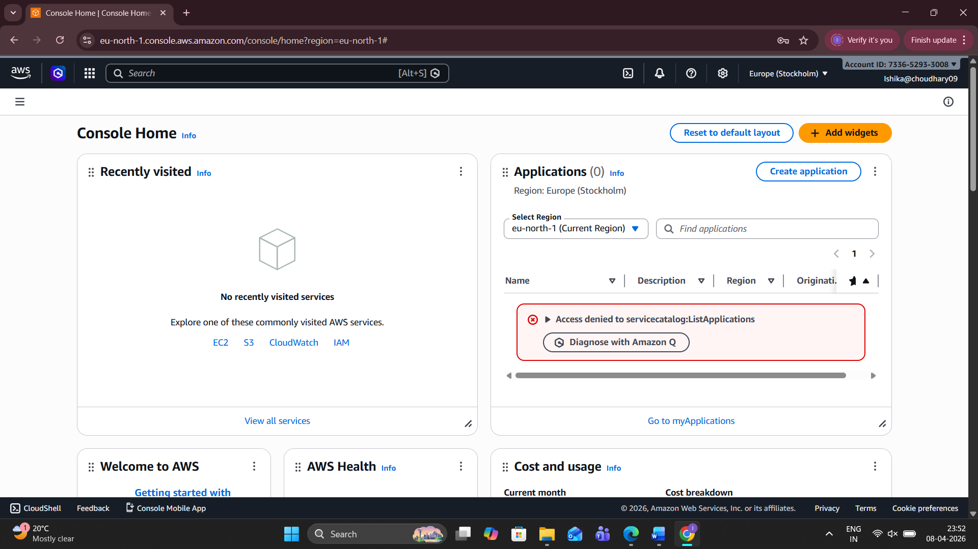
Step 10: Access Denied on Console Home
On the AWS Console Home, several widgets like AWS Health and Cost and usage show "Access denied." This is because the IAM user "ranjeet" was only given S3 permissions, so they cannot view billing or health data.
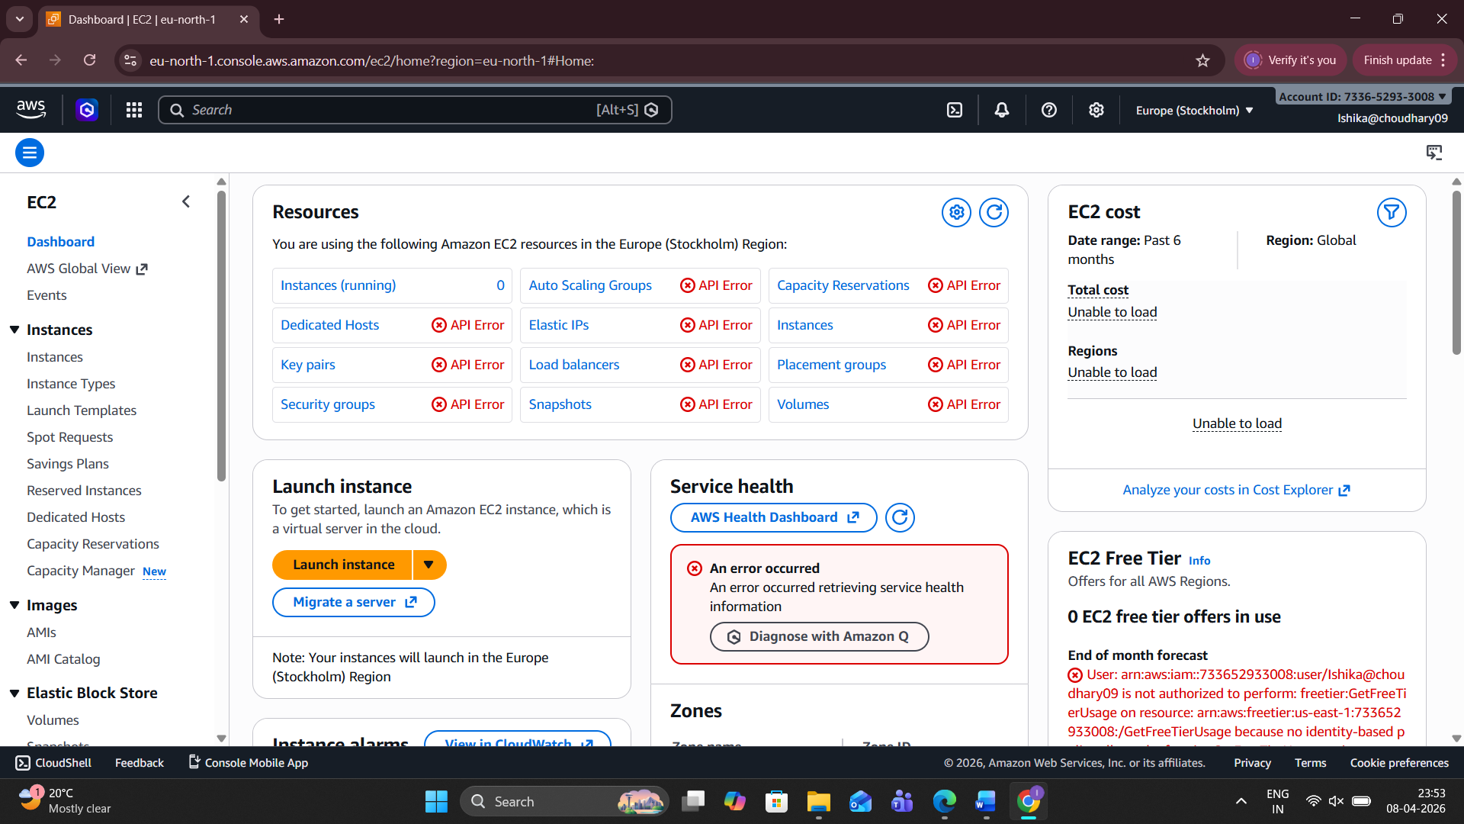

Step 11: EC2 Dashboard Errors
The user navigates to the EC2 Dashboard. Almost all resource sections (Instances, Security Groups, etc.) show "API Error." Since the user does not have EC2 permissions, the console cannot retrieve any data for these services.
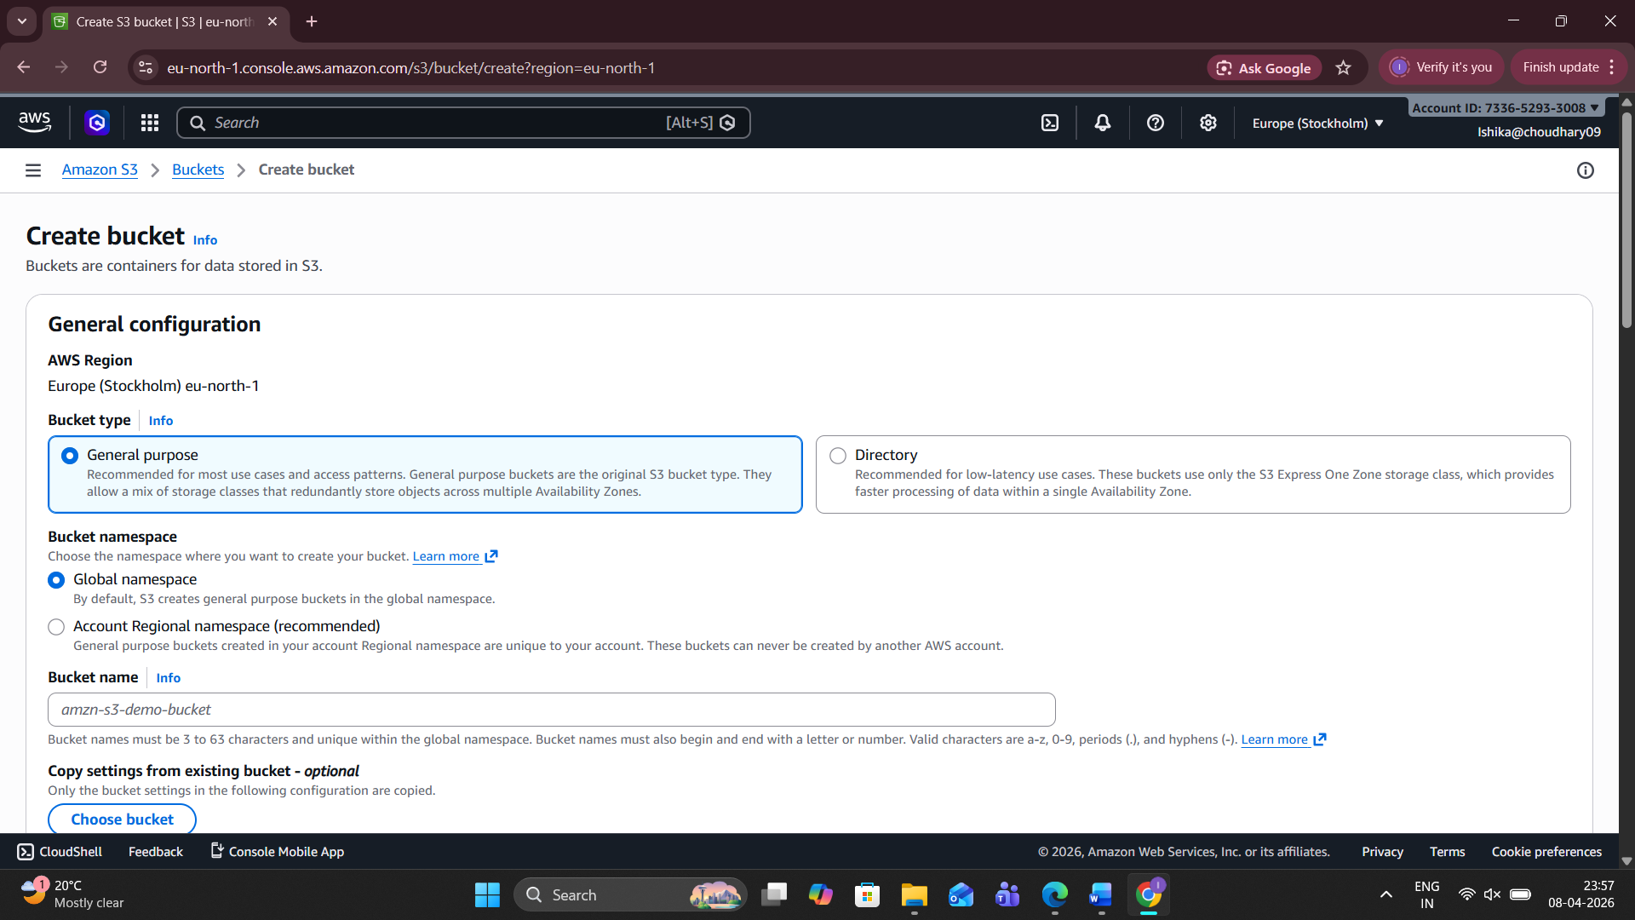

Step 12: Account Attribute Errors
Continuing in the EC2 section, red error boxes appear under "Scheduled events" and "Account attributes." These messages explicitly state that an error occurred because the user is not authorized to perform these actions.

